

**UNIVERSITY**

**CHUKA**

**FACULTY OF SCIENCE, ENGINEERING AND TECHNOLOGY**

**DEPARTMENT OF COMPUTER SCIENCE AND ICT**

**COMP 402: COMPUTER SYSTEMS PROJECT DOCUMENT**

**IPASS VISITOR MANAGEMENT SYSTEM**

**NAME: FREDRICK OCHIENG’**

**REG NO: EB1/16967/14**

**SUPERVISOR NAME: MR FREDRICK MUTHENGI**

Submitted by Fredrick Ochieng to Chuka University, in partial fulfillment of the requirements for the degree of Bachelor of Science in Computer Science.

**DATE OF SUBMISSION: 20/04/2018**

**DECLARATION BY THE STUDENT**

This research project, which is my original work, has not been presented for a degree in any other University. No part of this research may be reproduced without the prior permission of the author and/or Chuka University.

Name of Candidate Sign Date

______________________ __________________ ____________

Department of Computer Science & ICT

Chuka University

**ACKNOWLEDGEMENTS**

I appreciate the opportunity given to pursue my Degree at Chuka University Faculty of Science, Engineering and Technology. Thanks go to the entire university, Computer Science department for providing a supportive and academically stimulating environment.

I would also like to acknowledge the Almighty God for granting me an opportunity to further my studies and for giving me the gift of life and for the success I have achieved so far and for the far you have made me reach.

I sincerely appreciate my family and my fellow Degree students for creating a pleasant and enabling learning environment for me. You were such a great family to associate myself with.

Last but not least I would like to acknowledge my able supervisor Mr. Fredrick Muthengi for the support and advice he offered me throughout this phase of my project. Thank you so much.

**ABSTRACT**

In many organizations in Kenya and the world at large, management of visitors at the premises is one of the major problems faced by the security and reception departments that are associated with the visitation. Currently, the manual system (paper log) is being used in the organizations.

This method is associated with many different challenges. These include:

* Long queues if there are many visitors to be served at a given time thus time consuming.
* Provision of incorrect details in cases where the visitor has to write the details by him/herself.
* Poor identification of visitors within the organization’s premises since the visitor badges provided does not bare the visitor’s details such as the name, Identity Number etc.
* Lack of knowledge of who is currently in the building since there is lack of signing out.

The objectives of the system are:

* To provide easy and faster access to the organization’s premises by the employees.
* To generate automatic notifications to host (individual to be visited) and to the visitor.
* To generate alerts and instant mailing and messaging.
* To generate overall reports.

**Table of Contents**

**CHAPTER ONE: INTRODUCTION** 1

**1.0 Introduction** 1

**1.1Background to the study** 2

**1.2 Statement of the Problem** 2

**1.3 Proposed Solution** 3

**1.3.1 Aim** 3

**1.3.2 Objectives** 3

**1.4 Justification** 3

**CHAPTER TWO: LITRETURE REVIEW** 4

**2.0 Domain Research** 4

**2.0.1History** 4

**2.0.2 Computer Visitor Management** 4

**2.1 Technical Research** 4

**2.2 Similar Systems** 5

**CHAPTER THREE: METHODOLOGY** 6

**3.1 INTRODUCTION** 6

**3.2 Research Methodology** 6

**3.3 System Development Life Cycle** 6

**3.3.1Planning** 6

**3.3.2 Implementation** 7

**3.3.3 Analysis** 7

**CHAPTER FOUR: SYSTEM ANALYSIS AND REQUIREMENTS DEFINITION** 8

**4.1 Introduction** 8

**4.2 Purpose** 8

**4.3 Scope** 8

**4.4 Data Collection** 8

**4.4.1 Observation** 8

**4.4.2 Questionnaires** 9

**4.4.2.1 System Analysis** 9

**4.5 Overview** 9

**4.6 Overall Description** 9

**4.6.1 Product Perspective** 10

**4.6.2 Product functions** 10

**4.6.3 User characteristics** 11

**4.6.4 Constraints** 11

**4.6.5 Assumptions and dependencies** 11

**4.7 Specific Requirements** 12

**4.7.1 External Interface Requirements** 12

**4.7.2 User interfaces** 12

**4.7.3 Communications interfaces** 13

**4.8 Functional Requirements** 13

**4.8.1 Registration** 13

**4.8.2 Check-In Visitor** 13

**4.8.3 Badge Printing** 13

**4.8.4 Check-Out Visitor** 13

**4.8.5 Administrator, Receptionist and Visitor Login** 14

**4.8.6 Retrieve Password** 14

**4.8.7 Searching** 14

**4.8.8 No match found** 14

**4.8.9 Manage Employees** 14

**4.8.10 Manage Visitor Types** 14

**4.8.11 Manage Reasons Types** 14

**4.8.12 Reports Generation** 14

**4.9 Performance Requirements** 15

**4.9.1 Prominent Search Feature** 15

**4.9.2 Usage of Search Feature** 15

**4.9.3 Usage of links** 15

**4.9.4 Response Time** 15

**4.10 Non-functional Requirements** 15

**4.10.1 Reliability** 15

**4.10.2 Availability** 15

**4.10.3 Maintainability** 16

**4.10.4 Portability** 16

**4.10.5 Security Requirements** 16

**4.11 Design Constraints** 16

**4.11.1Hardware Drive Space** 16

**4.11.2Application Memory Usage** 16

**CHAPTER FIVE: SYSTEM DESIGN** 17

**5.0 Introduction** 17

**5.1 Project Scope** 17

**5.2 Hardware Interfaces** 17

**5.3 Software Interfaces** 18

**5.4 Design Consideration** 18

**5.4.1 Assumptions** 18

**5.4.2 Goals and Guidelines** 18

**5.4.3 Constraints** 19

**5.5 System Architecture** 19

**5.6 Component and Process Design** 20

**5.6.1 System Use Case Diagram** 20

**5.6.2 Flowcharts** 21

**5.6.3 E-R Diagram** 22

**5.7 Database Design** 22

**5.7.1 Visitor Management System Database and Tables Design** 23

**5.7.2 Administrator_login table** 23

**5.7.3 Receptionist_login table** 23

**5.7.4 Receptionist_details** 24

**5.7.5 Visitations_table** 24

**5.7.6 Visitor_category table** 24

**5.7.7 Purpose_for_visit table** 25

**5.7.8 Hosts_details table** 25

**5.8 User Displays and Outputs Reports** 25

**5.8.1 User Interfaces** 25

**5.8.2 Login Interface** 25

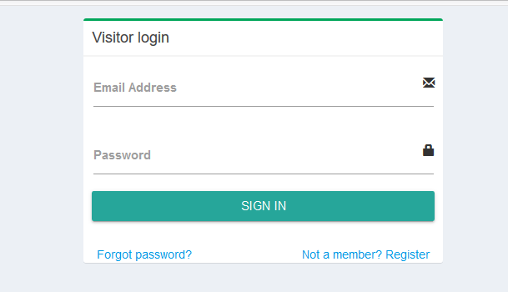 26

**5.8.3 Register form for receptionist** 26

**5.8.4 Register form for hosts** 27

**5.8.6 Receptionist Panel**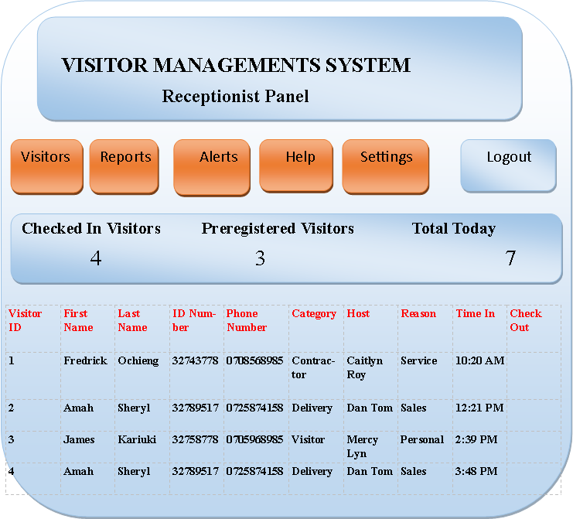 28

**CHAPTER SIX: IMPLEMENTATION** 30

6.1 Integrated Development Implementation 30

6.2 Database Implementation 30

6.2.1 Database Tables 30

6.2.2 Database Tables Relationships 30

6.3 Interface Implementation 30

6.3.1 User Registration Form 30

6.3.2 User Login 31

6.3.3 Visitation Booking Form 32

**6.3.4 User’s Pending Visitations** 32

**6.3.5 User’s Completed Visitation** 32

6.4 Receptionist Module 33

6.4.1 Receptionist Login Form 33

6.4.2 Pending Visitations 34

6.4.3 Checked in Visitors 35

6.4.4 Visitation Reports 35

6.5 Administrator Module 36

6.5.1 Administrator Login 36

6.5.2 Add Receptionist Form 37

**6.5.3 Add Employee (Host) Form** 37

**CHAPTER SEVEN: TESTING** 39

**7.1 Emptiness Validation** 39

**7.2 User Incorrect Username** 39

**7.3 Invalid ID Number Validation** 40

**7.4 Add Employee Emptiness Validation** 40

**7.5 ID Number Already Registered Validation** 41

**CHAPTER EIGHT** 42

**8.1 Conclusion** 42

**8.2 Recommendations** 42

**REFERENCES** 43

**LIST OF FIGURES AND TABLES**

**List of figures**

**Figure 1 Software Development Life Cycle 6**

**Figure 2 System architecture 19**

**Figure 3 System use case diagram 20**

**Figure 4 System flowchart 22**

**Figure 6 Login interface 26**

**Figure 7 Registration form for receptionist 26**

**Figure 8 Registration form for hosts 27**

**Figure 9 Administrator panel 27**

**Figure 10 Receptionist panel 28**

**Figure 11 Database tables 30**

**Figure 12 User registration form 31**

**Figure 13 User login form 31**

**Figure 14 Visitation booking form 32**

**Figure 15 User's pending visitation 32**

**Figure 16 User's completed visitations 33**

**Figure 17 Receptionist dashboard 33**

**Figure 18 Receptionist login form 34**

**Figure 19 Pending visitations 34**

**Figure 20 Checked in visitors 35**

**Figure 21 Report generation form 35**

**Figure 22 Administrator dashboard 36**

**Figure 23 Administrator login form 37**

**Figure 24 Add receptionist form 37**

**Figure 25 Add host form 38**

**Figure 26 Reports empty fields 39**

**Figure 27 Incorrect username validation 39**

**Figure 28 Invalid ID Number validation 40**

**Figure 29 Add host empty fields validation 40**

**Figure 30 ID Number already registered 41**

**LIST OF TABLES**

**Table 1 ipass database and tables 23**

**Table 2 Administrator login table 23**

**Table 3 Receptionist login table 24**

**Table 4 Receptionist details table 24**

**Table 5 Vistations table 24**

# **CHAPTER ONE: INTRODUCTION**

## **1.0 Introduction**

Organizations are tapping into rich potentials of visitation by different people on a daily basis. This is due to the many different services provided by such organizations. On a daily basis, different visitors pop in at different times to meet specific individuals within the organization for example human resource managers, chief executive officers, head of departments.

With these visitations by different people in an organization, visitor management has become one of the major areas of concern in an organization thus proper management of this key aspect must be taken into consideration so that the key operations of the organization can be done in a smooth way without any problem.

Apart from the visitors, this whole aspect of the visitations involve the employees of the organization from the point where the visitor is accepted to the organizations premises to the point of meeting the specific individual(s) who are the employees of the organization. Due to this, proper management must be put into place to ensure that efficiency is maintained within the organization in matters relating to visitations.

Without a proper management of such visitors, the organization may be faced with different challenges. To safeguard the wellbeing and security of the employees within the organization, the whereabouts of each and every visitor within the organization must be known to the employees and to the front desk so that the visitors can be tracked when situation demands.

To achieve this, there must be a platform where the visitors must be accepted in first through some form of verifications before they meet the individuals/employees within the organization. With such a platform, the individual visitor can be easily traced because his/her whereabouts are known to the front desk team.

With such a platform, less time is spent to clear a visitor compared to the traditional paper log (manual system) used currently in many organizations. The need of such a platform can also help the organizations to keep the records of its visitors so that frequent visitors can be signed in faster, generate reports of the visitors and also send automatic notifications.

If the manual system of visitor management is eliminated in our organizations and the proposed system adopted, then undoubtedly such organizations will benefit from efficient management of its visitors thus easing the workload of the front desk team (reception).

## **1.1Background to the study**

The rapid development and expansion of many organizations and institutions in Kenya and the world at large has led to increased number of services being offered in such organizations/institutions thus leading to increased number of visitations in a given organization.

Current research shows that many organizations are faced with various challenges in matters relating visitor management. This is due to the manual handwritten paper log that is being used. While this method is perceived as quick and easy, there are security threats associated with it and it also leaves the visitors details for everyone to see.

To ensure effective and successful management, the organizations/institutions must not only be innovative, resourceful and dynamic, but also able to interact well with people both within and outside the organization/institution. The people outside the organization/institution are the visitors who come to the organization to seek or acquire some services provided by such organizations/institutions.

For the purpose of achieving success as an organization/institution, the organization head or the whole fraternity must come up with a solution to incorporate a platform for visitor management to help eliminate the flaws associated with the manual handwritten paper log.

With such a platform, the whole aspect of visitor management can be achieved efficiently so that organization’s operations can run smoothly without any problems.

## **1.2 Statement of the Problem**

In many organizations in Kenya and the world at large, management of visitors at the premises is one of the major problems faced by the security and reception departments that are associated with the visitation. Currently, the manual system (paper log) is being used in the organizations.

This method is associated with many different challenges. These include:

* Long queues if there are many visitors to be served at a given time thus time consuming.
* Provision of incorrect details in cases where the visitor has to write the details by him/herself.
* Poor identification of visitors within the organization’s premises since the visitor badges provided does not bare the visitor’s details such as the name, Identity Number etc.
* Insecurity due to lack of visitor’s image capture.
* Lack of knowledge of who is currently in the building since there is lack of signing out.

In the management point of view it is difficult to deal with the visitors during rush hours with the manual system during the checking-in and checking-out making the visitors to wait in long queues. Tracking of visitor(s) is also difficult since checking of the records is done manually thus time consuming and can lead to inaccuracy in information collected for such purpose.

## **1.3 Proposed Solution**

The proposed system for visitor management will be a web based system that runs on Microsoft Windows. The system will have three users; Administrator, receptionist and the users (visitors) who will be accessing the system using the login credentials provided and perform the actions that are implemented.

### **1.3.1 Aim**

My main aim is to analyze, design, develop, implement and evaluate a web based system that is used for visitor management in an organization so as to eliminate the manual system that uses paper. Due to the very many challenges associated with the manual system, it is a very crucial step made to ensure that the challenges are eliminated by introducing the web based system

### **1.3.2 Objectives**

* To provide easy and faster access to the organization’s premises by the visitors.
* To generate automatic and instant notifications to host (individual to be visited) and to the visitor.
* To generate overall reports of the visitations.

## **1.4 Justification**

Creating a workplace environment where employees feel safe is of the utmost importance. Feelings of safety and comfort are key to overall productivity and success. The employees will feel more comfortable knowing that any strangers or guests on –site have been processed through a Visitor Management System (VMS).

Basically, Visitor Management System performs the task of tracking who is currently in your premises. At advanced levels, VMS can track when guests arrive and control the length of their stay in your premises.

# **CHAPTER TWO: LITRETURE REVIEW**

## **2.0 Domain Research**

In the modern world, organizations need to take care of security measures concerning visitors’ management and tracking. Corporate offices tend to get very many visitors on a daily basis for reasons such as interviews, parcel and deliveries etc. By introducing Visitor Management System (VMS), organizations can track visitors on daily basis by introducing procedures such as registration by providing Identity cards, visitor approvals, pass or badge and record keeping.

**2.0.1History**  
Since September 11, 2001, many companies and government agencies enhanced building security by including access control and documenting visitors. The most defining event illustrating the need to enhance school security worldwide occurred in Beslan, Russia on September 1, 2004. A group of mostly Chechen terrorists took over a school and held more than 1,100 hostages for three days until Russian security forces stormed the building. A severe firefight ensued and ultimately over 350 people died, including 184 children. Shortly afterwards, Deputy Secretary of Education Eugene W. Hickok issued a policy letter to all U.S. schools listing “a closed campus approach to limit visitors” as one effective measure of enhancing school security. Since then, several new computerized visitor management systems have been introduced to meet this need (Hagan, 2012).

### **2.0.2 Computer Visitor Management**

In addition to physical barriers limiting organizations access to one point, many organizations have discovered the need to improve their process for recording who is entering and exiting the facility. The basic paper log (manual method) is limiting because it is slow and provides little information other than name and time.

Several computer based systems are available that provide a wealth of information to enhance both security and front office efficiency. Many systems have a kiosk type environment where a visitor essentially checks himself in much like the paper log (manual method), but the system has the ability to record much more information quickly. This additional information can  
include a photo of the visitor, the reason he/she is there, to what location he is going or who is he/she going to see, a time stamp, and many more (Hagan, 2012)

## **2.1 Technical Research**

This involves the study on similar system to know the functionality features of the existing system, this is to find the flaws in the existing systems and to take note and suggest some good features. The limitations of the existing system are the either reduced or totally eliminated so that the new system can function efficiently compared to the existing system.

## **2.2 Similar Systems**

Visitor Management Software is working system that allows the visitor to call the individual to be visited from the gate and requires someone to answer from inside the house. Visitor Management Software is the outcome of motivation that has come out of the drawbacks or loopholes of the present system of working.

Visitor Management System (VMS) is developed using the trends in information technology which provides a feature to capture visitor information by using identification proof of the visitor and save them to a database that is centralized. (Spectra, 2015)

Lobby guard Kiosk system has helped the school organization in savings its time at the same time the student’s safety is not at risk. Functionality provided by the system has helped the organizations in saving the time of its employees otherwise they had to attend to the visitor at the entrance whenever a new visitor arrives. The organization is exited with the features offered by the system since it saved employees time and takes care of the student’s safety (LobbyGuard , 2013).

Installation of the system creates an impression to the visitor that safety is the top priority for the organization. The system takes care of the sign-in process which is streamlined by powerful solutions offered by the system. The system tracks every visitor who enters the school premises. Sign-in and sign-out processes are tracked by the system with other details such as whom has the visitor come to meet with reason for the visit (LobbyGuard, 2013).

Happy Visitor Management System manages all the activities that are involved in managing a visitor. The main idea of the system is to make the visitor an easy activity making it a trouble free visit (Happy visitor, 2014)**.**

# **CHAPTER THREE: METHODOLOGY**

## **3.1 INTRODUCTION**

Methodology refers to the analysis of the methods used appropriate to a field of study. It is a systematic way of accomplishing certain tasks and is defined as a collection of procedures, techniques, tools and documentation aids that helps a software developer to speed up and simplify the software development process (Pressman, 2001).

This chapter describes the methodology for this dissertation and the methodology that is used for system development.

## **3.2 Research Methodology**

The purpose of the research methodology is to provide a view of the methods that was applied into this research. In addition, it defines the system development life cycle (SDLC) for developing the system. The project will be developed using waterfall software development process model.

## **3.3 System Development Life Cycle**

In order to evaluate this project, the methodology based on System Development Life Cycle (SDLC), generally three major step, which is planning, implementing and analysis.

MAINTANANCE & SUPPORT

IMPLEMENTATION

DESIGN

ANALYSIS

PLANNING

**Figure 1 Software Development Life Cycle**

### **3.3.1Planning**

To identify all the information and requirement such as hardware and software, planning must be done in the proper manner. The planning phase have two main elements namely data collection and the requirements of hardware and software

#### **3.3.1.1Data collection**

Basically there are two types of data:

1. **Primary data**

Primary data are those data which are collected for the first time, taking a sample, representing a population. It is not a published data, it is problem specific data collected by the researcher, and it becomes the secondary data for everybody, other than the researcher. It can be collected in five ways: Observational research, Focus groups research, Survey research, Behavioral data Experimental research.

1. **Secondary data**

Secondary data are those data, which are already published. It may be useful for many other persons than the researcher who published it. There are various sources of secondary data collection which includes Government sources, Commercial sources, Industry sources, miscellaneous sources.

The main data source used in this project research was the secondary data source captured in the literature review section.

#### **3.3.1.2 Hardware and software requirement**

At this stage, requirements are detailed to an extent that to prove and decide on the architecture for the proposed system. Requirements of the project are detailed to such an extent that understanding of the architectural risk and the scope is realized for further planning.

### **3.3.2 Implementation**

At this stage, the project is developed and completed. The implementation of the system is done to the level of deployment. User feedback is taken by deploying the earlier version of the system implemented

### **3.3.3 Analysis**

The analysis stage is the final stage in this methodology where the two points will be done. The analysis is based on the performance of the system related to where the output must be performed well and successful and the second is identifying the conclusion.

# **CHAPTER FOUR: SYSTEM ANALYSIS AND REQUIREMENTS DEFINITION**

## **4.1 Introduction**

The introduction of the Software Requirements Specification (SRS) provides an overview of the entire SRS with purpose, scope, definitions, acronyms, abbreviations, references and overview of the SRS. The aim of this document is to gather and analyze and give an in-depth insight of the complete **iPass** **Visitor Management System**. The detailed requirements of the system are provided in this document.

## **4.2 Purpose**

The purpose of this document is to give a detailed description of the requirements for the “Visitor Management System. It will illustrate the purpose and complete declaration for the development of the system. It will also explain system constraints, interface and interactions with other external applications. This document is primarily intended to be proposed to a customer for its approval and a reference for developing the first version of the system for the development team.

## **4.3** **Scope**

Visitor Management System is a web based system that is used for the management aspects of visitors within an organization. The user (visitor) creates an account whereby he/she provides the required details. Upon successful registration, he/she can book for a visitation at the organization where he/she selects the appropriate visitation details. When he/she arrives at the receptionist, he/she is checked in upon verification of his/her details (the visitation code that was sent to him/her through either text or email and the ID Number). These are done by the receptionist. Upon completion of the visitation, the visitor is checked out.

This SRS is also aimed at specifying requirements of the system to be developed. The standard can be used to create software requirements specifications directly or can be used as a model for defining an organization or project specific standard. It does not identify any specific method, nomenclature or tool for preparing an SRS.

## **4.4 Data Collection**

Data collection methods that were used were:

* Observation
* Questionnaires

### **4.4.1 Observation**

I carried out a research about how some of the current organizations and institutions manage their employees. In the organizations and institutions I visited, I found out that the manual (paper log) system was being used for visitor registration. In some of these organizations, the visitor is issued with the sheet of paper at the gate to fill for him/herself. After the visitor finishes the visitation, he/she just leaves the premises without even the knowledge of the security officers who issued him/her the sheet of paper.

### **4.4.2 Questionnaires**

During my research, I designed some questionnaires which I issued to Chuka University security department to help me come up with the desired system. I also designed some questionnaires for the students because at one time they might have paid a visit to any organization/institution.

### **4.4.2.1 System Analysis**

The analysis of the data collection methods above especially the questionnaires are as follows;

Of all the questionnaires filled ,100% of the organizations use the manual paper log system to register visitors and the form of storage for the visitors’ details is the books where they keep the records.According to this method, generation of reports seems to be difficult since the books where the visitors; details are stored may go missing thus ineffective methiod to be used.

Through this method, checking out visitors is not done appropriately thus very difficult to know the total number of visitors currently within the organization.

The suggestion proposed by the people is that a computerized system for visitor management is designed and implemented to help curb the problems associated with the manual paper log.

On the side of the visitors, 50% were registered using the manual paper log while the other 50% were registered using desktop computers. 50% the participants in the questionnaire questions supported the idea of having the web based system that I proposed to design and implement.

## **4.5 Overview**

The remainder of this document includes three sections and appendixes. The second section provides an overview of the system functionality and system interaction with other systems. This section also introduces the user(s) and their interaction with the system. Further, the chapter also mentions the system constraints and assumptions about the product.

The third section provides the requirements specification in detailed terms and a description of the different system interfaces. Different specification techniques are used in order to specify the  
requirements more precisely for different audiences. Conclusion is also captured in this section.

## **4.6 Overall Description**

This section will give an overview of the whole system. The system will be explained in its context to show how the system interacts with other systems and introduce the basic functionality of it. It will also describe what type of stakeholders that will use the system and what functionality is available for each type. At last, the constraints and assumptions for the system will be presented.

### **4.6.1** **Product Perspective**

Visitor Management System (VMS) will consist of three parts; admin dashboard, receptionist dashboard and the user (visitor) dashboard. The administrator will use the dashboard to perform administrative functions. The receptionist’s dashboard is used by the receptionist to perform his/her functions such as checking in and checking out the visitors. The visitor dashboard is used by the visitor to perform functions such as booking for a visitation.

Since this system uses information in real time, a database is needed to store the visitor details so that they can be loaded when needed by all the users of the system. The web application will interact with the database to store the visitor details and also load (get) the data from the database.

This system is can be integrated with the Employee management System so that the details of the employees can be captured since when the visitor is being registered he/she must specify the employee he/she intends to visit. But note that the system (VMS) is not a component of the EMS.

### **4.6.2 Product functions**

The web application will be used mainly by the administrator, receptionist and the visitors. The overall system is managed by the administrator. The visitor creates an account first then he/she can proceed to book for a visitation. When the visitor arrives at the reception, he/she will provide the visitation code sent to him/her through either text or email to counter check what the receptionist received during the visitation booking. He/she will also have to provide his/her national identity card so that confirmation can be done. Upon successful authentication, the visitor is checked in.When the visitor ends his/her visitation then the receptionist will check out the visitor

With the web application the administrator and the receptionist will be able to generate reports about the visitors. For example the administrator and the receptionist will be able to view the list of current visitors within the premises or the list of pre-registered visitors who have not been checked in yet.

The system will allow the administrator to be able to register the employees (hosts in the case of the system) together with their departments within the organization because when the visitor is being registered he/she must specify the host (employee) he/she wishes to visit. In addition to that, the system will allow the administrator to be able to perform some administrative functions such as:

* Add/delete visitor categories because the receptionist needs to specify the type of visitor during visitor registration. For example delivery, contractor, visitor etc.
* Add/delete reason for visit because this must also be specified by the receptionist during registration of the visitor for example personal visitor, service/repair etc.
* Add/delete department because this is required by the administrator during employee (host) registration.

Summary of the functions of the system are:

* Visitor registration
* Checking in visitors
* Printing badges
* Checking out visitors
* Generating reports
* Searching for a visitor
* Employee (host) registration

### **4.6.3** **User characteristics**

The general characteristics of the users of the system (administrator, receptionist and visitors) are described in detailed.

The administrator and receptionist are expected to have some technical skills related to IT so as to enable them use the system. Apart from that, they are also expected to have some knowledge on the usage of android operating system (basically how to use a smartphone) .This also applies to the visitors.

The education level of the users should be a level that at least can enable them to use the system. The users should be experienced in using systems so to manage the system with ease.

### **4.6.4 Constraints**

The web application will be constrained by the functionality of the SMS Server for sending text message notifications to the hosts and the visitors since the SMS Server may be temporarily be down sometimes thus the text message may not be passed to the host.

### **4.6.5 Assumptions and dependencies**

The first assumption about the system is that the visitor knows the employee (host) he/she intends to visit. He/she either knows the employee (host) by official name or the title of his/job.

This will help in quick identification of the host so that time is not wasted.

Another assumption is that the administrator and the receptionist knows the host (employee’s) status in terms of availability i.e. the administrator and the receptionist knows whether the host is present or absent from the organization at a particular moment. When an employee (host) is on a leave for example, it is assumed that the administrator and the receptionist will be notified so that the employee’s status can be changed from active to inactive. This will help the receptionist to either proceed with registration of the visitor or not.

## **4.7 Specific Requirements**

This section contains all the requirements of the system i.e. functional and non-functional requirements.

### **4.7.1 External Interface Requirements**

This section provides a detailed description of all inputs into and outputs from the system. It also gives a description of the hardware, software and communication interfaces and provides basic prototypes of the user interface.

### **4.7.2 User interfaces**

When the administrator, receptionist and visitor launch the system for the first time he/she should see a homepage containing the login link where each one will be able to select their respective login links which contains a text field where he/she will be required to enter the username and a password field where he/she will be required to enter the password. The page also contains a login button and “forgot password?” hyperlink. When the administrator enters the correct details (username and password) then the system should direct him/her to the administrator page otherwise he should get error message.

The administrator page/dashboard will have some items in the navigation bar such as:.

* Employee – should contain icons/buttons such as Register, Update, and Delete.
* Reports – should contain icons/buttons such as Current Visitors, Visitor History, and Pre-registered Visitors.

The receptionist dashboard will contain modules such as;

* Visitors-check in, check out
* Reports- to generate overall reports

The visitor dashboard will contain modules such as;

* Visitations- unattended, finished and cancelled visitations.
* Book Visitation- to book a visitation.
* Profile- to view profile details and also to edit the details.
* Feedback- to send a feedback or rather to comment on the kind of services he/she received at the organization he visited.

### **4.7.3 Communications interfaces**

Communication takes place between the different parts of the system because they depend on each other. In this system the communication takes place between the different parts of the system and the database.

## **4.8 Functional Requirements**

This section includes the requirements that specify all the fundamental actions of the software system.

### **4.8.1** **Registration**

The visitor will register where he/she will provide the details including username and password.

The administrator of the system will also register the receptionist whereby the registration details will be stored in a database. The receptionist will then be able to create his/her own password then continue to login to the system.

### **4.8.2** **Check-In Visitor**

Given that the receptionist is logged in he/she should be able to check in a visitor once he/she has booked for visitation.

### **4.8.3** **Badge Printing**

Once the visitor is checked in he/she should be provided with a printed badge that is used to identify him/her within the premises

### **4.8.4** **Check-Out Visitor**

Given that the receptionist is logged in he/she should be able to check out a visitor once he/she has finished his/her visitation.

### **4.8.5 Administrator, Receptionist and Visitor Login**

The receptionist and visitors should be able to login to the system using the username and password provided during registration and retrieved from the database. Note that there is no registration for the administrator but the username and password are stored in the database.

### **4.8.6 Retrieve Password**

The administrator, receptionist and visitors should be able to retrieve the password in case he/she forgets the password either through email or text message.

### **4.8.7 Searching**

The administrator and the receptionist should be able to do a search for the visitors. The result should be displayed in list view.

### **4.8.8 No match found**

If no match is found from the search then the administrator and receptionist should be informed but kept on the search page in order to get the possibility to conduct another search.

### **4.8.9** **Manage Employees**

Given the administrator has logged in he/she should be able to manage employees (hosts) delete/add/ or activate/inactivate an employee.

### **4.8.10** **Manage Visitor Types**

Given that the administrator has logged in he/she should be able to add/delete any visitor type/category in the system.

### **4.8.11 Manage Reasons Types**

Given that the administrator is logged in he/she should be able to add/delete any reason for visit in the system.

### **4.8.12 Reports Generation**

The administrator, receptionist and visitors should be able to generate reports about the visitations to the organizations.

## **4.9 Performance Requirements**

The requirements in this section provide a detailed specification of the user interaction with the software and measurements placed on the system performance.

### **4.9.1** **Prominent Search Feature**

The search feature should be prominent and easy to find for the users (in this case the administrator, receptionist and visitors) of the system.

### **4.9.2 Usage of Search Feature**

The different search options should be evident, simple and easy to understand so that the search operation can be done quickly.

### **4.9.3 Usage of links**

The links in the system for example the “forgot password?” hyperlink should be prominent and should be evident that it is a usable link. Selecting the link should only take one click.

### **4.9.4 Response Time**

The search operation and other operations within the system should be faster. For example the search operation should not take more than 2 seconds.

## **4.10 Non-functional Requirements**

### **4.10.1 Reliability**

This is the reliability that the system should give on the search operations done.

### **4.10.2 Availability**

The system should be available as long as the computer is powered on.

### **4.10.3 Maintainability**

The application should be easy to extend. The code should be written in a way that it favors implementation of new functions.

### **4.10.4 Portability**

The system should be portable with several versions of Windows operating system.

### **4.10.5 Security Requirements**

Since this is a very sensitive system, there must be some form of users (administrator, receptionist and visitor) authentication. The users is required to enter the username and password which must be correct to enable them login to access the system. Note that the password should be encrypted to enhance security.

If the user enters wrong input(s) he/she should be notified and in the case where they forget the password, they should be able to reset the password using the “forgot password” hyperlink.

## **4.11 Design Constraints**

This section includes the design constraints on the software caused by the hardware

### **4.11.1Hardware Drive Space**

The web application needs not less than 250 MB of Hard Drive Space.

### **4.11.2Application Memory Usage**

The amount of memory occupied by the web application should not be less than 250 MB.

# **CHAPTER FIVE: SYSTEM DESIGN**

## **5.0 Introduction**

This SDS will cover the web application for Visitor Management System. The system will be a tool that helps organizations to manage their visitors on a daily basis. The users of the system are the administrator, receptionist and visitors.

The visitor will be required to register and then do a booking for a visit then he/she can be checked in to the organization’s premises. After the visitor has finished his/her visitation, he must be checked out of the premises so that the system can know who is currently in the organization’s premises.

The web application is aimed at eliminating the hitches associated with the manual paper log system currently used in many organizations as well as institutions. Such problems are as follows;

* Long queues if there are many visitors to be served at a given time thus time consuming.
* Provision of incorrect details in cases where the visitor has to write the details by him/herself.
* Poor identification of visitors within the organization’s premises since the visitor badges provided does not bare the visitor’s details such as the name, Identity Number etc.
* Lack of knowledge of who is currently in the building since there is lack of signing out.

The web application is thus recommended because it eliminates the above problems associated with the manual system.

This document will provide details on the scope, system design, database design, user displays and output display and References and Appendices

## **5.1 Project Scope**

The SDS is used to specify the design of the system in question. The first section shows the introduction and design considerations for the system. The second section illustrates the system architecture for the VMS. The third section illustrates the component and process design while the fourth section illustrates the database design for the system and the fifth section illustrates the user interface design. The last section is for the appendices.

## **5.2 Hardware Interfaces**

## **5.3 Software Interfaces**

Visitor Management System will interact with the DBMS to carry out several specific tasks associated with the system. The interaction will aid in verification of the users of the system (Administrator, receptionist and the visitors in this case). Some of the tasks that will be performed in this case are insertion of the user details (receptionists) and those of the visitors to the database and querying the user details to be used for the purposes of authentication.

## **5.4 Design Consideration**

This section describes many of the issues that needed to be addressed or resolved before attempting to devise a complete design solution.

### **5.4.1 Assumptions**

The first assumption about the system is that the visitor knows the employee (host) he/she intends to visit. He/she either knows the employee (host) by official name or the title of his/job.

This will help in quick identification of the host so that time is not wasted.

Another assumption is that the receptionist knows the host (employee’s) status in terms of availability i.e. the receptionist knows whether the host is present or absent from the organization at a particular moment. When an employee (host) is on a leave for example, it is assumed that the administrator will be notified so that the employee’s status can be changed from active to inactive

### **5.4.2 Goals and Guidelines**

The main goal of the web application to eliminate the manual system that uses paper. Due to the very many challenges associated with the manual system, it is a very crucial step made to ensure that the challenges are eliminated by introducing the web application.

* To provide easy and faster access to the organization’s premises by the visitors.
* To generate automatic notifications to the visitor and to the host (individual to be visited).
* To generate alerts and instant messaging.
* To generate overall reports.
* To provide security to the employees.

Another goal of the application is to process visitors securely and efficiently with workplace safety being the main goal.

Another goal is to provide adequate assessment of staff based on the number of visitors and their reason for the visit. It is also helpful in keeping track of the visitors’ information for efficient and easy communication.

### **5.4.3 Constraints**

* **Platform** – the web application must work on a Desktop Computer or PC, android phone, iPhone or tablet.

## **5.5 System Architecture**



**Figure 2 System architecture**

Users of the system interacts directly with the system through the provided user interfaces of the system at the user interface layer which then provide some functional services for each user of the system depending on the user privileges as defined by the system. These functions are captured at the functional service layer of the system.

In the functional services layer, the data input or request is routed to the appropriate functional module in accordance with the users’ login and account type. Through these modules, the users will interact with the database via the SQL server.

Data transfers in the system occur in two directions i.e. the data is sent to the database through the inputs made by the users of the system or retrieval of data from the database initiated by the users. This is done at the user interface layer.

## **5.6 Component and Process Design**

### **5.6.1 System Use Case Diagram**



**Figure 3 System use case diagram**

### **5.6.2 Flowcharts**

Flowcharts show the flow of data from external entities into the system, and from one process to another within the system. The administrator of the system is able to access all the parts of the system whereas the receptionist is restricted to accessing some parts of the system.

#### **5.6.2.1 General System Flowchart**

**Figure 4 System flowchart**

### **5.6.3 E-R Diagram**

## 

## **5.7 Database Design**

During the design stage of the system, the database design is required. A database is created for the system and the relational tables are the created within the database to store the required data. During the database design, relational data integrity aspects such as domain constraints are taken care of to ensure the correctness of the value assigned to the attributes.

Different tables have been used to design the database for the system. These following are some of the tables used:

* **Receptionists** table which store the information about the receptionists added/ registered by the administrator. Note that when the organization or institution is big then there may be more than one receptionist.
* **Hosts** table which contain the basic information about the hosts (employees of the organization) so that when the visitor is being registered by the receptionist, the host can be queried from this table.
* **Administrator_login** table which contains the username and password for the administrator for the purpose of logging into the system.
* **Users_table** which contains the registered users
* **Receptionist_login** table which contains the username and password for the administrator for the purpose of logging into the system.
* **Visitations_table** which contains all visitations made by the users.
* **Visitor_category** table which contains the visitor categories accepted by the system. These are either added or deleted by the administrator.
* **Purpose_for_visit** table which contain the purposes for visit accepted by the system. These are also added or deleted by the administrator.

The basic approach for the design of the database tables relies on relational algebra. This approach entails relational data structures for example relational keys such as the primary and foreign keys which are specified accordingly.

There are some basic rules for this approach that have been followed during the database tables (relational design). These include:

* **The relation has a distinct name-**the tables in the database have different names.
* **Each attribute has a distinct name-** each and every column of the tables have alsohave different names
* No duplicate rows because of the aspect of the primary key.
* Each cell of the relation contains one atomic value
* The values of an attribute are from the same domain

### **5.7.1 Visitor Management System Database and Tables Design**

|  |  |
| --- | --- |
| **DATABASE** | **TABLES** |
| Ipassvmsdb | * Administrator_login * Receptionist_login * ReceptionistP_details * Hosts_details * Visitations_table * Visitor_category * Purpose_for_visit |

Table ipass database and tables

### **5.7.2 Administrator_login table**

|  |  |  |  |  |
| --- | --- | --- | --- | --- |
| **Name** | **Type** | **Null** | **Extra** | **Assign** |
| Username | Varchar(100) | No |  | Primary Key |
| Password | Varchar(50) | No |  |  |

**Table 2 Administrator login table**

### **5.7.3 Receptionist_login table**

|  |  |  |  |  |
| --- | --- | --- | --- | --- |
| **Name** | **Type** | **Null** | **Extra** | **Assign** |
| Username | Varchar(100) | No |  | Primary Key |
| Password | Varchar(50) | No |  |  |
|  |  |  |  |  |

**Table 3 Receptionist login table**

### **5.7.4 Receptionist_details**

|  |  |  |  |  |
| --- | --- | --- | --- | --- |
| **Name** | **Type** | **Null** | **Extra** | **Assign** |
| First_Name | Varchar(100) | No |  |  |
| Last_Name | Varchar(100) | No |  |  |
| ID_Number | Int(8) | No |  | Primary Key |

**Table 4 Receptionist details table**

### **5.7.5 Visitations_table**

|  |  |  |  |  |
| --- | --- | --- | --- | --- |
| **Name** | **Type** | **Null** | **Extra** | **Assign** |
| Visitor_id | Int(10) | No | AUTO_INCREMENT | Primary Key |
| First_Name | Varchar(50) | No |  |  |
| Last_Name | Varchar(50) | No |  |  |
| ID_Number | Int(8) | No |  |  |
| Phone_Number | Varchar(10) | No |  |  |
| Visitor_Category | Varchar(50) | No |  |  |
| Host | Varchar(50) | No |  |  |
| Purpose | Varchar(50) | No |  |  |
| Time_In | Varchar(30) | No |  |  |

**Table 5 Vistations table**

### **5.7.6 Visitor_category table**

|  |  |  |  |  |
| --- | --- | --- | --- | --- |
| **Name** | **Type** | **Null** | **Extra** | **Assign** |
| Category_id | Int(10) | No | AUTO_INCREMENT | Primary Key |
| Category_Name | Varchar(50) | No |  |  |

**Table 5 Visitor category table**

### **5.7.7 Purpose_for_visit table**

|  |  |  |  |  |
| --- | --- | --- | --- | --- |
| **Name** | **Type** | **Null** | **Extra** | **Assign** |
| Purpose_id | Int(10)_ | No | AUTO_INCREMENT | Primary Key |
| Purpose_Name | Varchar(50) | No |  |  |

**Table 6 Purpose for visit table**

### **5.7.8 Hosts_details table**

|  |  |  |  |  |
| --- | --- | --- | --- | --- |
| **Name** | **Type** | **Null** | **Extra** | **Assign** |
| First_Name | Varchar(100) | No |  |  |
| Last_Name | Varchar(100) | No |  |  |
| ID_Number | Int(8) | No |  | Primary Key |
| Department | Varchar(30) | No |  |  |
| Post | Varchar(30) | No |  |  |

**Table 7 Host details table**

## **5.8 User Displays and Outputs Reports**

### **5.8.1 User Interfaces**

During the design stage of the system some interfaces were designed so that the users can interact with. These interfaces aid in the main functionalities of the system to be accomplished.

### **5.8.2 Login Interface**

The username and the password field for the three users are authenticated from the database table and in case wrong details are put then a warning message is displayed. In case the password is forgotten then the user can do a reset by clicking the hyperlink (Forgot Password?).The Login button is clicked so that they can login. The figure below shows the login form for the visitor.

### **C:\Users\fredriq\Pictures\Screenshots\Screenshot (9).png**

**Figure 6 Login interface**

### **5.8.3 Register form for receptionist**

This is the form used by the administrator for the registration of new receptionist. In the below figure, all the fields must not be left empty for successful registration. In addition to that, correct details must be put for example first name text field should not accept digits. After all fields have been entered then the Register button is clicked for registration.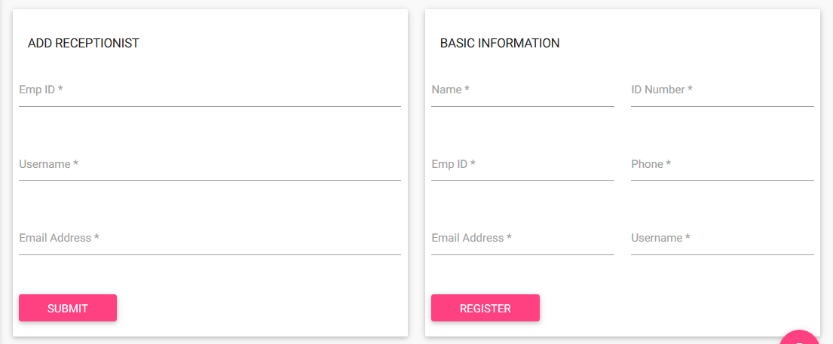

**Figure 7 Registration form for receptionist**

### **5.8.4 Register form for hosts**

This is the form used by the administrator for the registration of the hosts (employees) of the organization. In the form below, all the fields must not be left empty for successful registration. In addition to that, correct details must be put for example first name text field should not accept digits. After all fields have been entered then the Register button.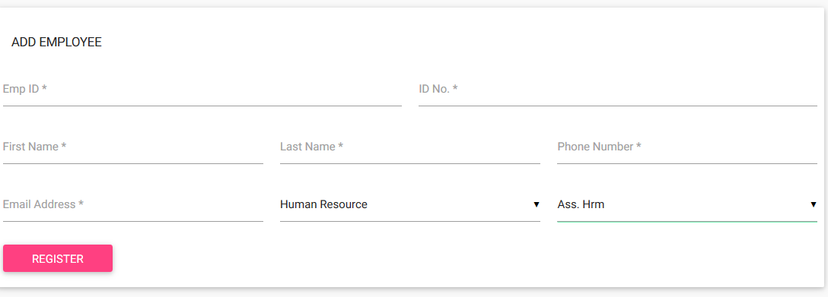

**Figure 8 Registration form for hosts**

**5.8.5 Administrator Panel**

Hosts

Visitors

Admin

Logout

**VISITOR MANAGEMENT SYSTEM**

**Administrator Panel**

**Administrator Panel**

Settings

Home

**Figure 9 Administrator panel**

The figure above shows the interface for the administrator of the system. When the administrator clicks the Hosts tab, a table of all hosts will be displayed and some icons will also be displayed. These icons include Add New Host, Delete, and Update.

Visitors tab contains the tables of the visitors (checked in visitors, pre-registered visitors and checked out visitors). It also contains icons for reports. In all the visitors’ tables, the administrator is only allowed to view. Admin tab contains icons for addition of visitor category and purpose for visit. Settings tab contains icon for changing password while the Logout button is clicked when the administrator wants to log out of the system.

### **5.8.6 Receptionist Panel**

**Figure 10 Receptionist panel**

The above figure shows the receptionist’s main interface. The visitors tab contains the visitors’ tables (checked in, pre-registered and checked out visitors). The reports tab contain icon for generating reports about visitation while the settings tab contains the change password fields.

# **CHAPTER SIX: IMPLEMENTATION**

This chapter captures the aspect of implementation of the **iPass Visitor Management System.** It entails the technologies that have been used to implement the system.

## 6.1 Integrated Development Implementation

During the implementation stage of the system, I used NetBeans IDE to write the PHP code. I also used XAMPP which contains the Apache web server to display the pages and MySQL for the database. For the database, I used phpMyAdmin module to help connect to the MySQL database.

## 6.2 Database Implementation

The system has a database named **ipassvmsdb** and it has a total of 13 tables.

### 6.2.1 Database Tables

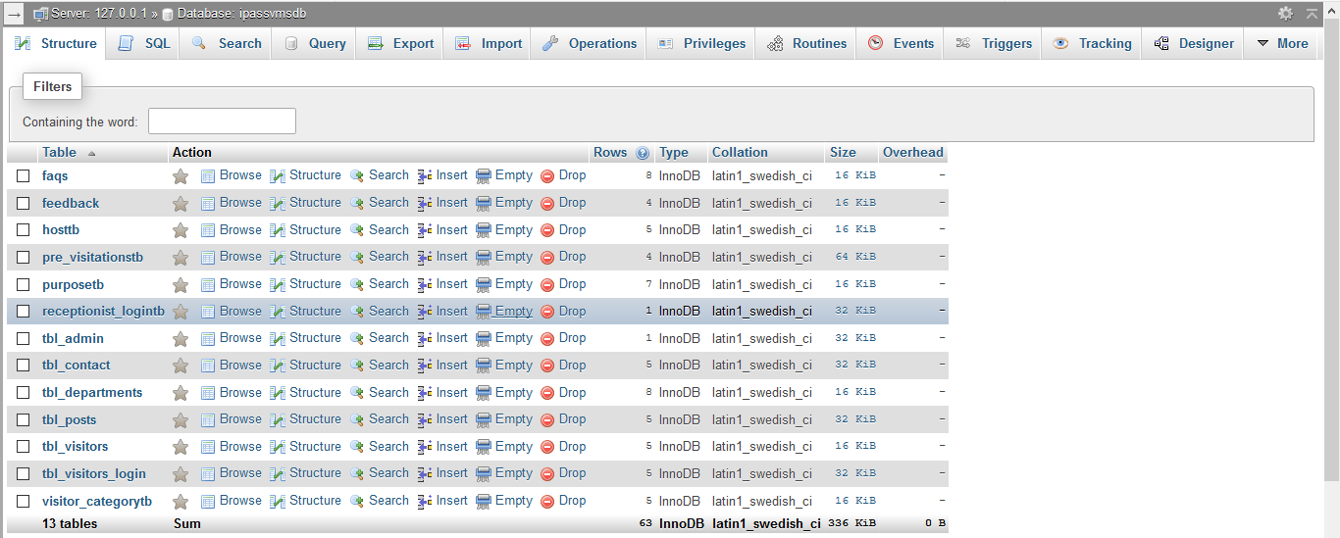

Figure 11 Database tables

Each table has constraint(s) such primary key that uniquely identifies a given data in a row and some also have foreign keys.

### 6.2.2 Database Tables Relationships

## 6.3 Interface Implementation

Interface implementation kick started by the implementation of the three modules namely user module, receptionist module and administrator module of which the very first step was the implementation of the registration interfaces of the users so that they can register. This was followed by the implementation of the login interfaces for the three modules so that they can login.

### 6.3.1 User Registration Form

The figure below shows the registration form for the user where all the fields must be filled for successful registration.

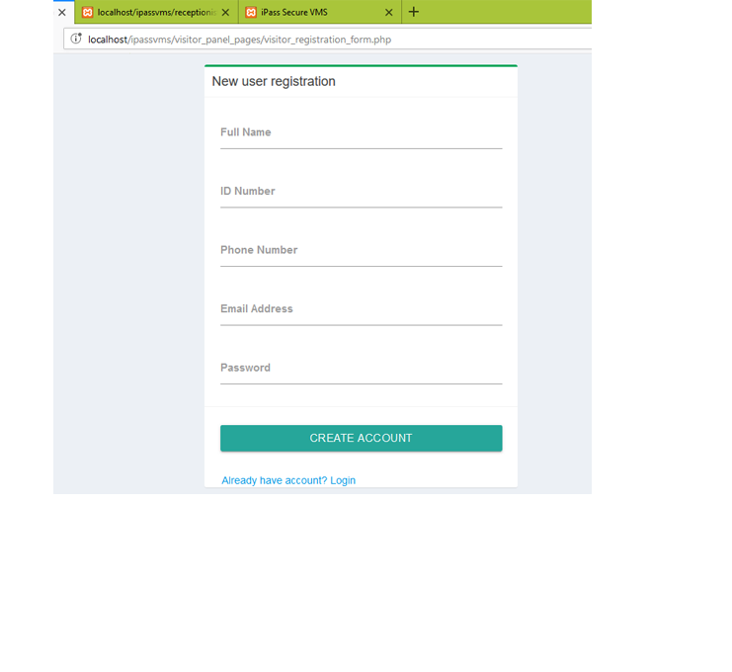

Figure 12 User registration form

### 6.3.2 User Login

The figure below shows the login form for the user. The form prevents illegal access to the system since only the registered users can login to the system to access the services provided by the system. For successful login, the user must fill all the fields and they must be correct.

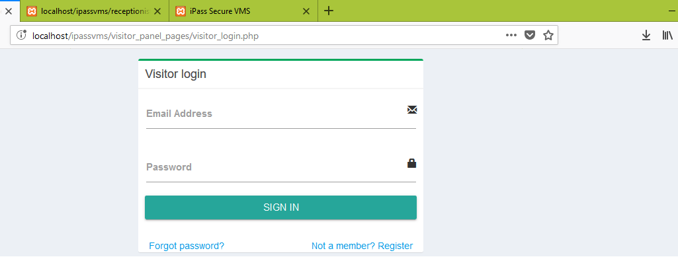

Figure 13 User login form

In the above figure if the user is not yet registered then he/she can click on the Not a member? Register link and he/she will be redirected to the registration form. If the user is registered and he/she forgets the password then he/she can click the Forgot password link so that he/she can be redirected to the recover password form.

### 6.3.3 Visitation Booking Form

The form below is for booking a visitation after the user is logged in. The user is required to select one of the options in the dropdown select boxes and then choose the date and time.

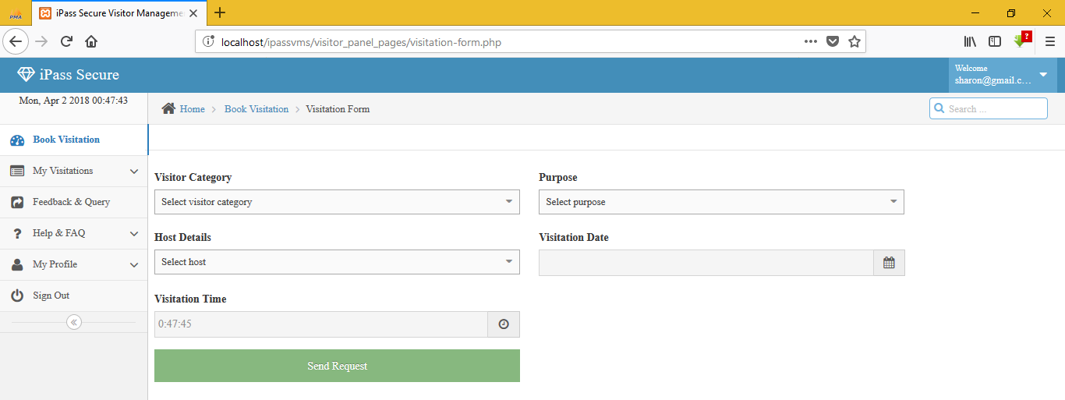

Figure 14 Visitation booking form

### **6.3.4 User’s Pending Visitations**

The figure below shows a table containing a record for the user’s pending visitations.

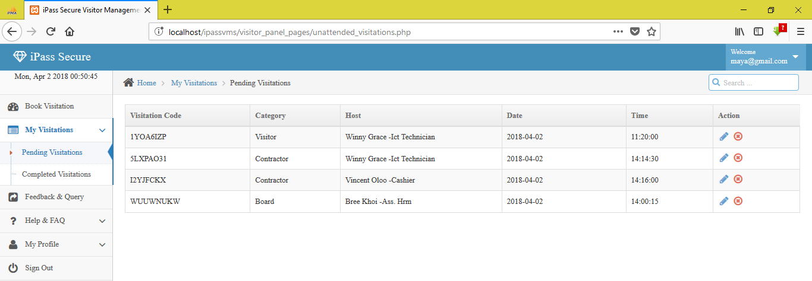

Figure 15 User's pending visitation

### **6.3.5 User’s Completed Visitation**

The figure below depicts a table containing all the records of a given user’s completed visitations.

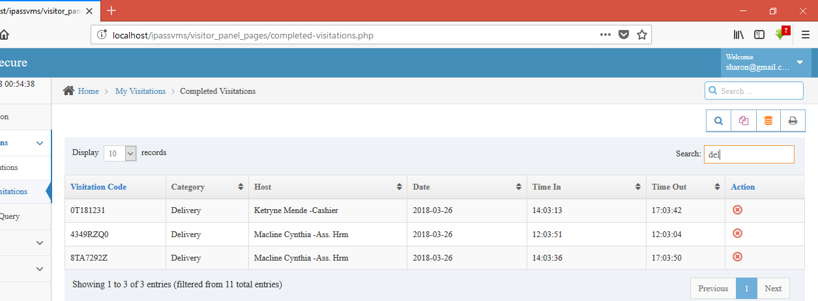

Figure 16 User's completed visitations

## 6.4 Receptionist Module

The figure below shows the module for the receptionist. It shows the checked in, checked out, pending visitors as well as canceled visitations for the day. It also has a search functionality to search for booked visitations in the future. This is implemented through the use of date picker.

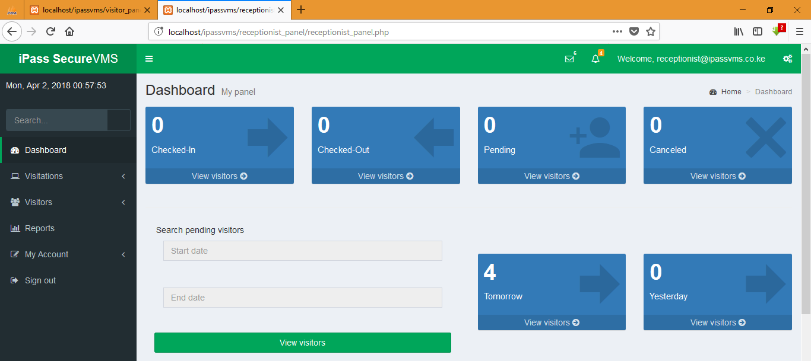

Figure 17 Receptionist dashboard

### 6.4.1 Receptionist Login Form

The figure below shows the login form for the receptionist. The form prevents illegal access to the system since only the registered receptionist(s) (added/registered by the administrator) can login to the system to access the services provided by the system. For successful login, the user must fill all the fields and they must be correct.

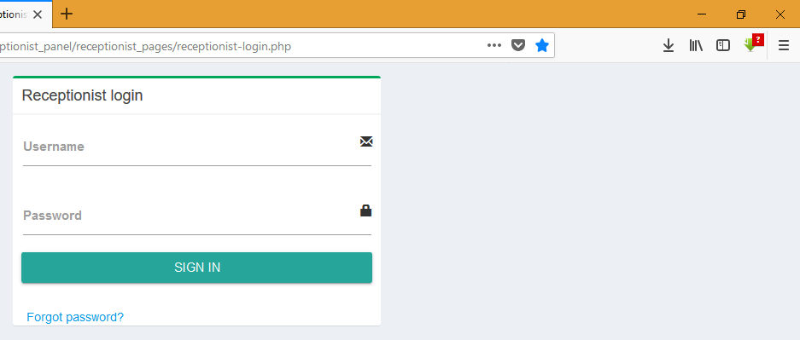

Figure 18 Receptionist login form

### 6.4.2 Pending Visitations

The figure below shows a table containing all the records for the visitations of that day (today). It has an icon which the receptionist clicks to check in the visitor.

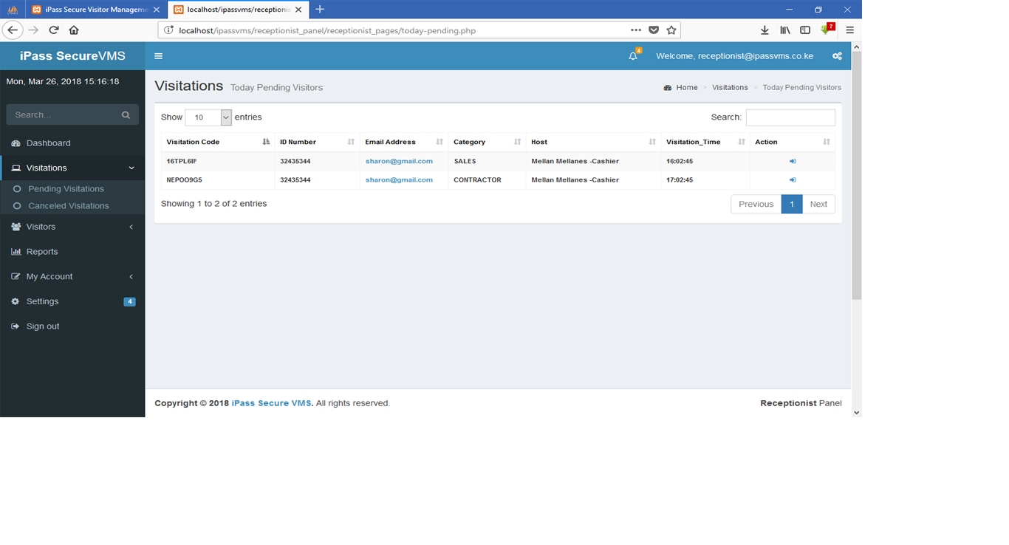

Figure 19 Pending visitations

### 6.4.3 Checked in Visitors

The figure below shows a table containing all the records for the checked in visitor at a particular time of that day (today). It has an icon which the receptionist clicks to check out the visitor.

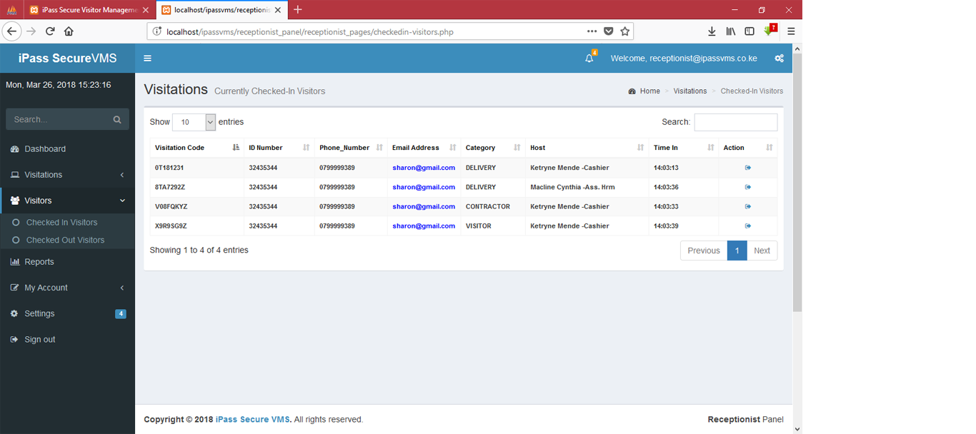

Figure 20 Checked in visitors

### 6.4.4 Visitation Reports

The figure below shows the various form the receptionist can fill to generate visitation reports. The receptionist is only required to choose one option at a time.

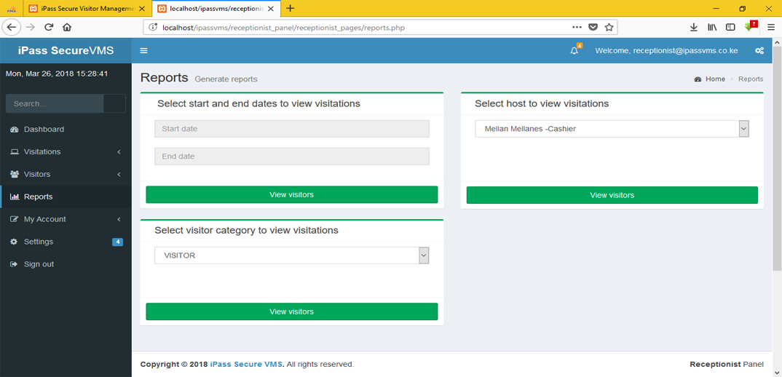

Figure 21 Report generation form

## 6.5 Administrator Module

The diagram below shows the administrator dashboard. It shows the checked in, checked out and pre-registered visitors for that particular day (today) as well as visitors for the next day. It also has a search functionality to search for future visitors.

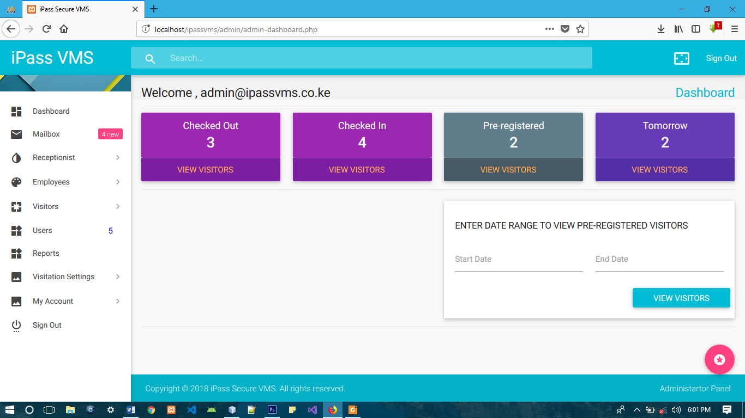

Figure 22 Administrator dashboard

### 6.5.1 Administrator Login

The figure below shows the login form for the administrator. The form prevents illegal access to the system to access the services provided by the system. For successful login, the administrator must fill all the fields and they must be correct.

  
Figure 23 Administrator login form

### 6.5.2 Add Receptionist Form

Below is the form used by the administrator to add/register receptionist. The admin is required to fill the fields for the Employee ID, Username and Email Address and the click the submit button. If the submitted details are correct then the details of that particular individual to be added as a receptionist are fetched from the database and the receptionist as added.

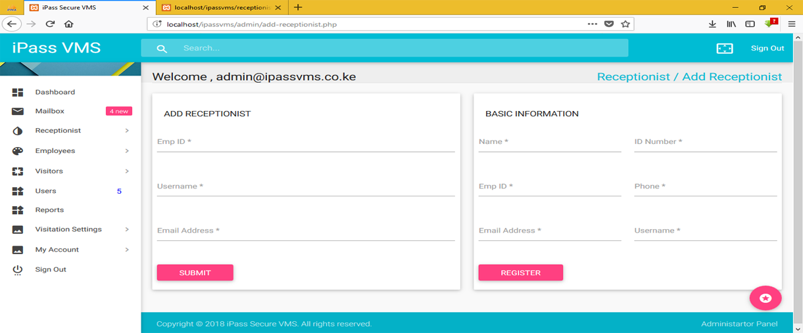

Figure 24 Add receptionist form

### **6.5.3 Add Employee (Host) Form**

Below is the form used by the admin to add an employee/host to the system. All the fields must be filled for successful registration

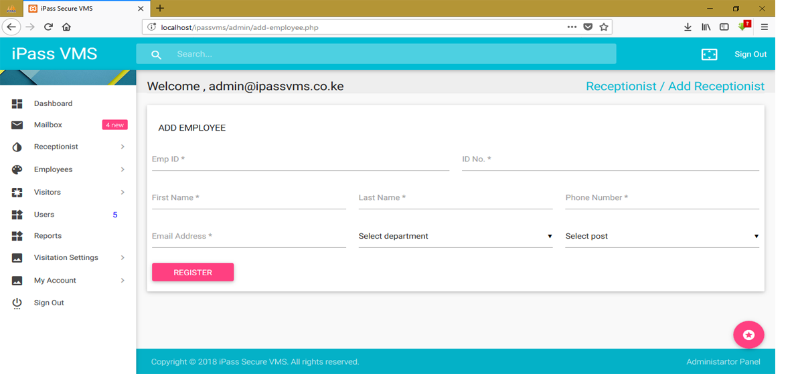

Figure 25 Add host form

# **CHAPTER SEVEN: TESTING**

This chapter contains some screenshots of the project depicting some various testing done on the system. Such testing include:

1. Testing for the emptiness of any field in the forms that should be submitted for processing.
2. Testing for the entry of invalid details in a form, for example entry of wrong format for phone number, email address, name, id number.
3. Entry of existing details in the forms that are unique identifiers to people and are already existing in the database, for example entry of an id number or email address that is already registered.
4. Entry of incorrect details in the forms, for example entry of incorrect username or password for the login forms.

Below are some of the screenshots.

## **7.1 Emptiness Validation**

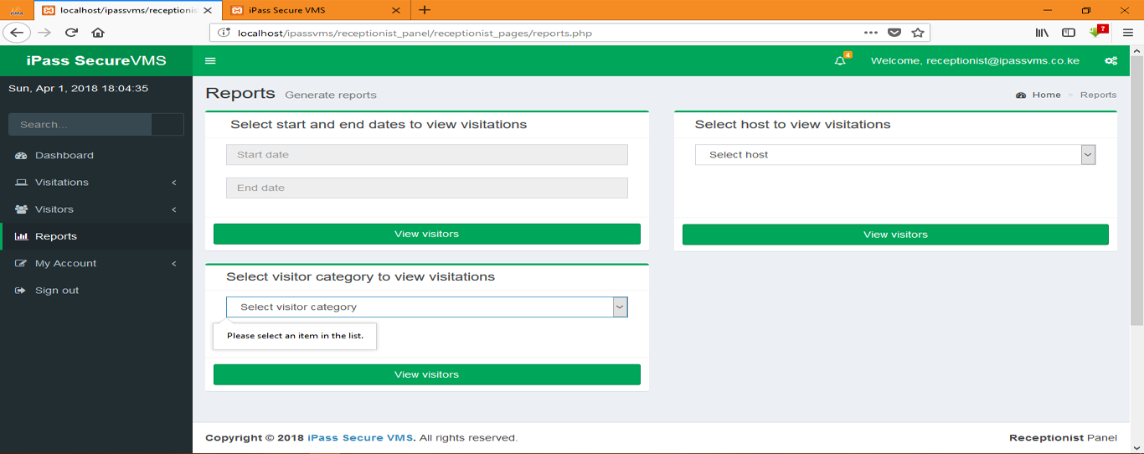

Figure 26 Reports empty fields

## **7.2 User Incorrect Username**

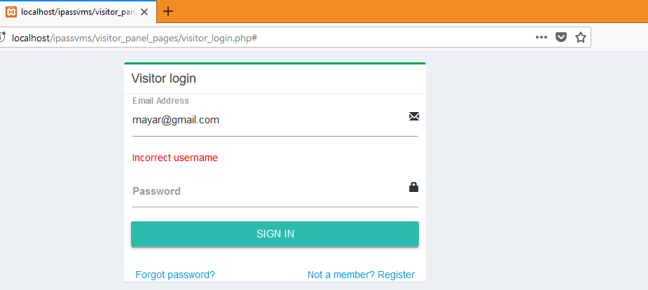

Figure 27 Incorrect username validation

## **7.3 Invalid ID Number Validation**

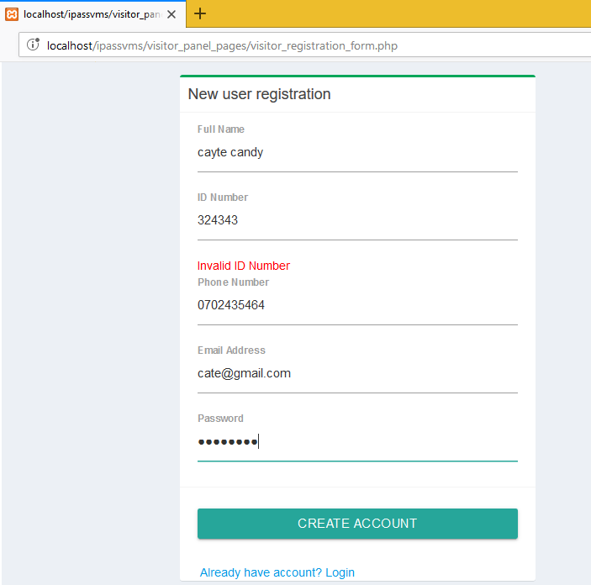

Figure 28 Invalid ID Number validation

## **7.4 Add Employee Emptiness Validation**

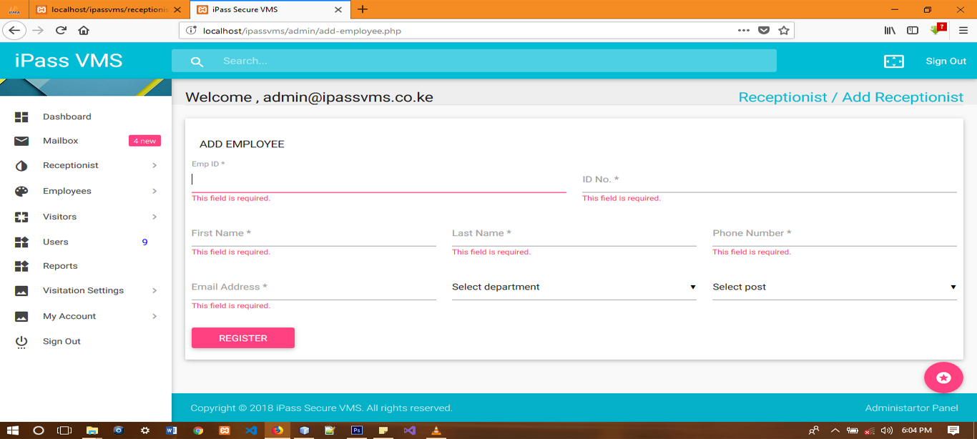

Figure 29 Add host empty fields validation

## **7.5 ID Number Already Registered Validation**

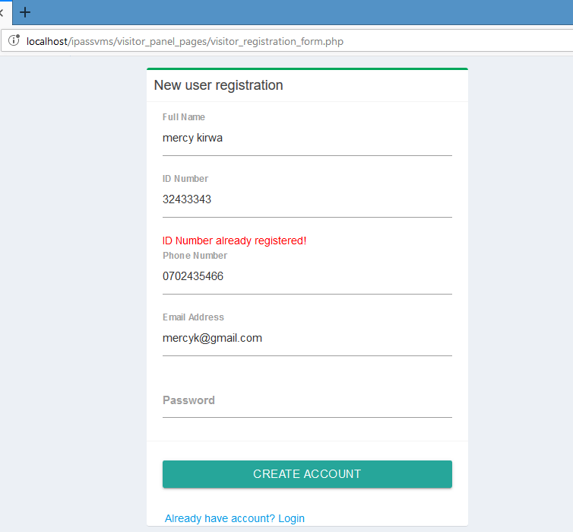

Figure 30 ID Number already registered

# **CHAPTER EIGHT**

## **8.1 Conclusion**

The visitor management system should be embraced by various organizations, institutions, government offices and any other firm that deal with visitors. Since the aspect of visitations cannot be avoided by any organization, this system enhances the whole aspect of visitor management within an organization.

The system will eliminate/ minimize the limitations associated with the manual visitor management within various organizations since it is efficient.

## **8.2 Recommendations**

I recommend organizations, institutions, government offices and any other firm that deal with visitors’ management to embrace and use this system so that they can gain the full potential of the system.

# **REFERENCES**

1. Anwar, A., 2014. A Review of RUP (Rational Unified Process). International Journal of Software Engineering (IJSE), 5(2), pp. 12-19.
2. Rational, 1998. Rational Unified Process Best Practices for Software Development Teams. Rational  
   Unified Process: Best Practices for Software development Teams, p. 2.Rational, 2002. Rational Unify Process (RUP), a Software Process Knowledge Base.. [Online] Available at:  
   <http://ref.web.cern.ch/ref/CERN/CNL/2002/001/SDT_RUP>
3. Rational, 1998. Rational Unified Process. Rational Unified Process: Best Practices for Software development Teams , p. 4-6
4. Happy visitor, 2014. HOW HAPPY VISITOR WORKS. [Online] Available at: <http://happy-visitor.in/>
5. Happy visitor, 2014. NEED FOR HAPPY VISITOR. [Online] Available at: <http://happy-visitor.in/>
6. LobbyGuard , 2013. home. [Online] Available at: <http://lobbyguard.com/>
7. IEEE Software Engineering Standards Committee, “IEEE Std 830-1998, IEEE Recommended Practice for Software Requirements Specifications”, October 20, 1998
8. Somerville, lan (2011) Software Engineering, USA, Boston; Pearson Education-9th Edition.
9. Chris Gane and Trish Sarson. *Structured Systems Analysis: Tools and Techniques.* McDonnell Douglas Systems Integration Company, 1977